KONERU LAKSHMAIAH EDUCATION FOUNDATION

COMPUTER SCIENCE DEPARTMENT

A Project Based Lab Report

On

ADVANCED HOSPITAL MANGEMENT SYSTEM

SUBMITTED BY:

S.NO | NAME | ID NUMBER
1 | M.GAYATHRI | 170030751
2 | K.DEVI NIMISHA | 170030503
3 | V.SAI SAMEERA | 170031145
4 | M.ARAVIND BABU | 170031513

UNDER THE ESTEEMED GUIDANCE OF

Mr.K.DAVID RAJU

Assistant Professor



KL UNIVERSITY

Green fields, Vaddeswaram – 522 502

Guntur Dt., AP, India

DEPARTMENT OF COMPUTER SCIENCE ENGINEERING



CERTIFICATE

This is to certify that this project based lab report entitled “ADVANCED HOSPITAL MANAGEMENT SYSTEM” is a bonafide work done by M.Gayathri (170030751), K.Devi Nimisha (170030503), V.Sai Sameera (170031145), and M.Aravind Babu (170031513) in partial fulfillment of the requirements for the award of degree in BACHELOR OF TECHNOLOGY in COMPUTER SCIENCE ENGINEERING during the Academic year 2018-2019.

Faculty in Charge Head of the Department
Dr.G.KRISHNAMOHAN Dr.V. HARI KIRAN

Project guide

Mr.K.DAVID RAJU

DEPARTMENT OF COMPUTER SCIENCE ENGINEERING

DECLARATION

We hereby declare that this project based lab report titled “ADVANCED HOSPITAL MANAGEMENT SYSTEM” has been prepared by us in partial fulfillment of the requirements for the award of degree “BACHELOR OF TECHNOLOGY in COMPUTER SCIENCE ENGINEERING” during the Academic year 2018-2019.
We also declare that this project based lab report is of our own efforts and it has not been submitted to any other university for the award of any degree.

Date:
Place: Vaddeswaram

M.Gayathri (170030751)
K.Devi Nimisha (170030503)
V.Sai Sameera (170031145)
M.Aravind Babu (170031513)

ACKNOWLEDGEMENT

Our sincere thanks to Mr.K.David Raju in the Lab for their outstanding support throughout the project and helping us successfully complete the work.
We express our gratitude to Dr.V. HARI KIRAN, Head of the Department for Computer science and Engineering for providing us with adequate facilities, ways and means by which we are able to complete this project based Lab.
We would like to place on record the deep sense of gratitude to the honorable Vice Chancellor; K L University for providing the necessary facilities to carry the project based Lab.
Last, but not the least, we thank all Teaching and Non-Teaching Staff of our department and especially my classmates and my friends for their support in the completion of our project based Lab.

M.Gayathri (170030751)
K.Devi Nimisha (170030503)
V.Sai Sameera (170031145)
M.Aravind Babu (170031513)

ABSTRACT

The main objective of our project is to implement an online software application for maintaining drugs information, patient’s information, medicines information and doctor’s information in a single application. This system will reduce manual work for maintaining records in files. The project is done based on java programming. This gives some necessary information about Hospitals. When we want to search any information regarding doctors, patients and treatment records, it is very difficult since we have to refer many registers for collecting the relevant information it takes lots of time. We can get all the information of any doctor and patient immediately and accurately. Here almost all work is computerized. So the accuracy is maintained. Maintaining backup is very easy .some of the issues can be solved easily by using this project.

INDEX
S.NO | TITLE | Page No
1 | Introduction | 7
2 | Existing System and its limitations | 8
3 | Objectives of proposed system | 9
4 | Advantages of proposed system | 10
5 | Software or Hardware requirement specifications | 11
6 | Code | 12-19
7 | Output Screenshots | 20-23
8 | Conclusion | 24
9 | References | 25

- INTRODUCTION

Our project Advanced Hospital Management System includes registration of patients, storing their details into the system and also computerized billing in the pharmacy, and labs. Our software has the facility to give a unique id for every patient and stores the details of every patient and the staff automatically. It includes a search facility to know the current status of each room. User can search availability of a doctor and the details of a patient using the id.

The Advanced Hospital Management System can be entered using a username and password. It is accessible either by an administrator or receptionist. Only they can add data into the database. The data can be retrieved easily. The interface is very user-friendly. The data are well protected for personal use and makes the data processing very fast.

- EXISTING SYSTEM

Existing system refers to the system that is being followed till now. Presently all the hospital functionalities are done manually. That is if a patient want to consult a doctor he can visit their till his chance called. This is making the person very difficult. Out_Patient and In_Patient tickets are distributed directly. The main disadvantage is time consuming.

2.1. LIMITATIONS OF EXISTING SYSTEM

- Lack of security of data.

- Time consuming.

- Consumes large volume of paper work.

- Manual work.

- No direct role for the higher officials.

To avoid all these limitations and make the system working more accurately it needs to be computerized.

- OBJECTIVES OF PROPOSED SYSTEM

The Hospital management system software is user-friendly software. The main objectives of the system is which shows and helps you to collect most of the information about Hospitality and Medical Services The system is very simple in design and to implement. The system requires very low system resources and the system will work in almost all configurations.

The main objectives of the proposed system can be enumerated as follows:

- Patients are easily allocated to the doctors.

- Doctors Search is possible.

- Today’s patient list help doctors to search their patients
- ADVANTAGES OF PROPOSED SYSTEM

The system is very simple in design and to implement. The system requires very low system resources and the system will work in almost all configurations.

- Security of data.

- Ensure data accuracy’s.

- Administrator controls the entire system.

- Reduce the damages of the machines.

- Minimize manual data entry.

- Greater efficiency.

- User friendly and interactive.

- Minimum time required.
- SOFTWARE/HARDWARE REQUIREMENT SPECIFICATIONS:-

Hardware/Software | Hardware / Software element | Specification /version
Hardware | Processor | Intel core to duo
 | RAM | 1 GB
 | Hard Disk | 100 GB
Software | OS | Windows XP
 | Java Related IDE | Java 5.1

- CODE

package mypack;
import java.util.*;
public class Hospital {
Scanner scr = new Scanner(System.in);
String name;
double[] doub = new double[100];
double amountdue;
double amountpaid;
double totalamount;
public Hospital(String name){
this.name = name;
amountdue=0;
amountpaid=0;
totalamount=0;
}
public void generatepaymentdetails(){
System.out.println("patient name :"+ " " + name );
System.out.println("total amount to be paid:"+ " "+ totalamount);
System.out.println("amount paid:"+" "+amountpaid);
System.out.println("due:"+" "+ (totalamount-amountpaid));
}
public void editpaymentdetails(double a,double b ) {
this.amountdue= a-b;
this.amountpaid = b;
this.totalamount = a;
}
public void paymentways(int n) {
int a =n;
double count=0;
double[] b = new double[n];
this.doub = b;
for(a=0;a<n;a++) {
System.out.println("Enter the "+" "+ (a+1)+" "+"payment patient has done" );
b[a] = scr.nextDouble();
count += b[a];
}
this.amountpaid=count;
}
public void allpaymentsdone() {
for(int j=0;j<doub.length;j++) {
System.out.println("The amount the patient paid for" +" " +j+ " time is:"+" "+doub[j]);
}
}
}
package mypack;
import java.util.*;
public class Diagnosis {
Scanner sc = new Scanner(System.in);
String name;
public Diagnosis(String name){
this.name = name;
}
public void diagnosisdetails()
{
System.out.println("The diagnosis that patient is suffering from : "+name);
}
public void editdiagnosis(int a)
{
if(a==1)
{
System.out.println("What is the update in diagnosis details:");
String s = sc.nextLine();
name=name.replace(name,s);
System.out.println("The patient is suffering from:"+name);
}
else
{
System.out.println("There is no update, the diagnosis complaint is: "+name);
}
}
public void querydiagnosis(int choice)
{
switch(choice)
{
case 1: System.out.println("There is a query in diagnosis details");
break;
case 0: System.out.println("There is no doubt in diagnosis details");
break;
}
}
public void generatereport(double a,double b,double c,double d)
{
System.out.println("Haemoglobin percentage: "+a);
System.out.println("White Blood Cells count: "+b);
System.out.println("Platelets count: "+c);
System.out.println("ESR count: "+d);
}
}
import mypack.*;
import javax.swing.*;
import java.util.*;
class hello
{
public static void main(String args[])
{
int g=0,u=0,q=0;
Scanner scr1 = new Scanner(System.in);
JFrame f = new JFrame();
f.setSize(200,300);
JLabel l = new JLabel("XYZ Hospital");
l.setBounds(50,50,100,200);
f.add(l);
f.setVisible(true);
System.out.println("##### MY HOSPITAL ####");
do
{
System.out.print("Enter the patients name:");
String name = scr1.nextLine();
Hospital obj = new Hospital(name);
System.out.print("Enter the diagnosis complaint:");
String name1 = scr1.nextLine();
Diagnosis o = new Diagnosis(name1);
System.out.println("For billing press 1");
System.out.println("For diagnosis press 2");
int choice = scr1.nextInt();
if(choice==1)
{
do
{
System.out.println("Enter the total bill to be paid by patient");
double a = scr1.nextDouble();
System.out.println("Enter the total bill paid by the patient");
double b = scr1.nextDouble();
obj.editpaymentdetails(a,b);
obj.generatepaymentdetails();
System.out.println("Please enter the number of transactions the patient had made:");
int k = scr1.nextInt();
obj.paymentways(k);
obj.allpaymentsdone();
obj.generatepaymentdetails();
System.out.println("Continue in billing press 1 else 0");
int i=scr1.nextInt();
g=i;
}
while(g>0);
}
if(choice==2)
{
do
{
o.diagnosisdetails();
System.out.println("Query in diagnosis: If yes press 1 else 0");
int m = scr1.nextInt();
o.querydiagnosis(m);
System.out.println("If there is a replacement in diagnosis complaint: if yes 1 else 0");
int n = scr1.nextInt();
o.editdiagnosis(n);
System.out.println("Enter hb percentage:");
double w = scr1.nextDouble();
System.out.println("Enter WBC percentage");
double x =scr1. nextDouble();
System.out.println("Enter platelets count");
double y = scr1.nextDouble();
System.out.println("Enter esr count");
double z = scr1.nextDouble();
o.generatereport(w,x,y,z);
System.out.println("Continue in doagnosis press 1 else 0");
int j=scr1.nextInt();
u=j;
}
while(u>0);
}
System.out.println("Enter 0 for leaving website");
int z=scr1.nextInt();
q=z;
}
while(q>0);
}
}

MODULE 4:

package project;
import java.io.*;
import java.lang.*;
public class user
{
public String usr_name;
public String pswrd;
public user(String usr_name,String pswrd)
{
this.usr_name=usr_name;
this.pswrd=pswrd;
}
}
import java.io.*;
import java.util.*;
import project.user;

public class mainexecution
{

public static void main(String[] args) throws IOException
{
DataInputStream dis=new DataInputStream(System.in);
int f=0;
ArrayList<user> a= new ArrayList<user>();
user u=null;
int g;
String pass;
String s;
try{
FileInputStream fis=new FileInputStream("database.txt");
ObjectInputStream oips = new ObjectInputStream(fis);
while( (u = (user)oips.readObject()) != null ){
a.add(u);}
fis.close();
oips.close();
}catch(Exception e){

}
System.out.println("-----------------------\nMenu\n1)Login\n2)create user\n3)update password\n4)display users\n5)exit\n-----------------------");
System.out.println("Enter user choice:");
int n = Integer.parseInt(dis.readLine());
while(true){
if(n==1)
{ f=0;
System.out.println("Enter user name");
String eu=dis.readLine();
for(user x:a)
{
if((x.usr_name).equals(eu)==true)
{ f=1;
System.out.println("Enter password:");
pass=dis.readLine();
if((x.pswrd).equals(pass)==true)
System.out.println("Login succesfull");
else
{System.out.println("Wrong password!login unsuccessfull");
break;}
}
}
if(f==0)
System.out.println("Wrong username!login unsuccessfull");

}
else if(n==2)
{
System.out.println("Enter a user name:");
String nu=dis.readLine();
System.out.println("password:");
String np=dis.readLine();
user ui=new user(nu,np);
a.add(ui);
}else if(n==3)
{
System.out.println("Enter username:");
s=dis.readLine();
f=0;
for(user x:a)
{
if((x.usr_name).equals(s)==true)
{ f=1;
System.out.println("Enter old password:");
pass=dis.readLine();

if((x.pswrd).equals(pass)==true)
{System.out.println("Enter New Password:");
pass=dis.readLine();
x.pswrd=pass;
}else
System.out.println("Wrong password");
break;
}
}
if(f==0)
System.out.println("Wrong user name\n");
}
else if(n==4){
System.out.println("------------------------------");
for (user x:a )
{ if(x==null)
{
System.out.println("No users registered");
break;
}
System.out.println("username:"+x.usr_name+"\t");
}
System.out.println("------------------------------");
}
else if(n==5)
{
FileOutputStream fout=new FileOutputStream("Database.txt");
ObjectOutputStream oops=new ObjectOutputStream(fout);
for(user x:a)
{
oops.writeObject(x);
}
fout.close();
oops.close();
break;
}
System.out.println("Enter a user choice:");
n = Integer.parseInt(dis.readLine());
}
}

}

- OUTPUT SCREENSHOTS

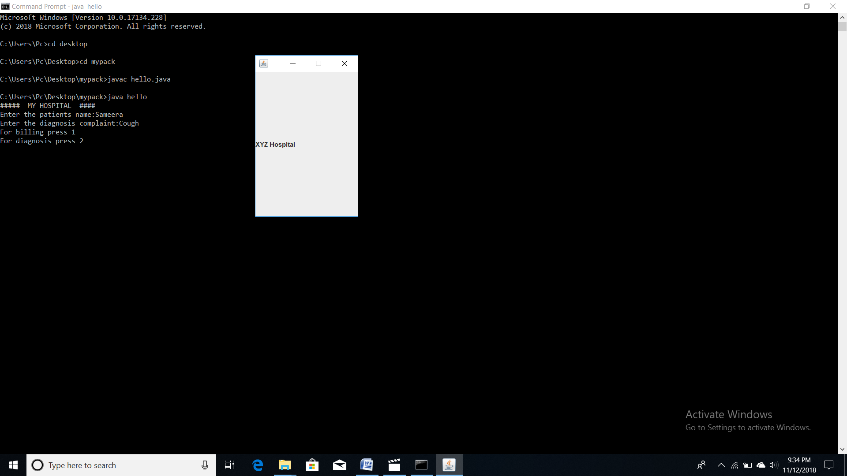

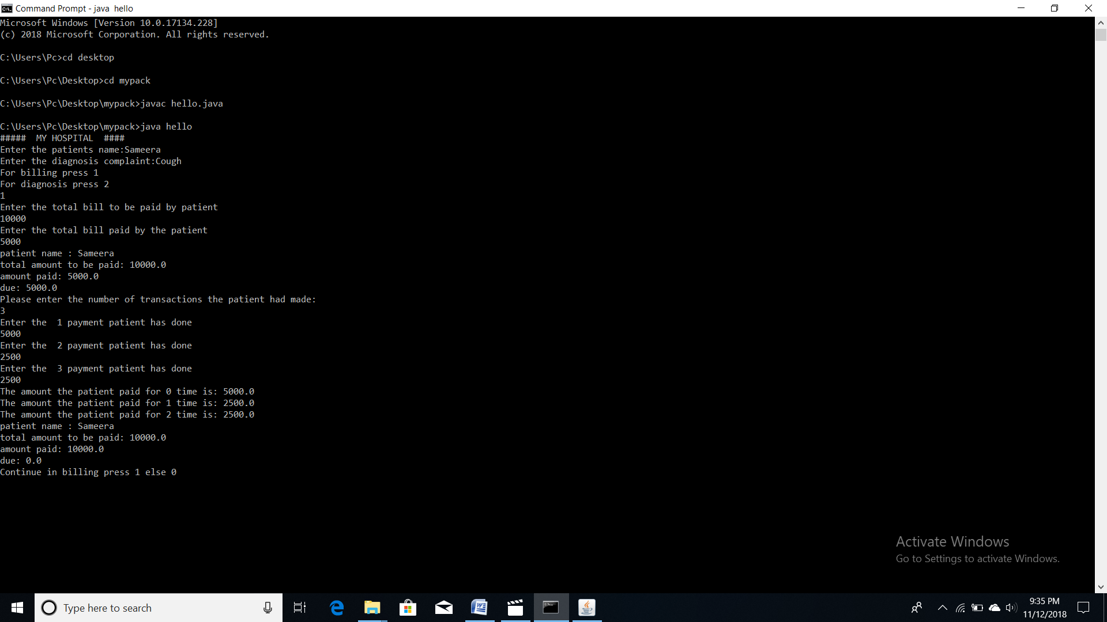

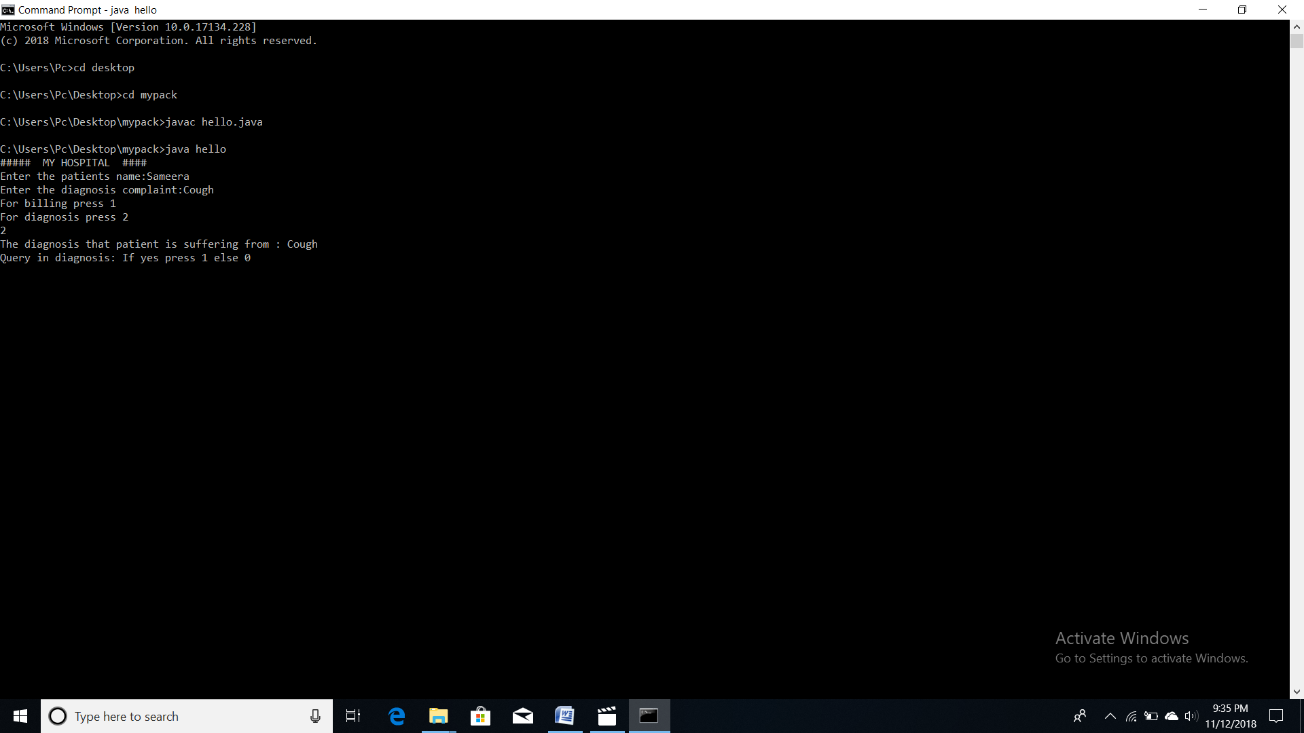

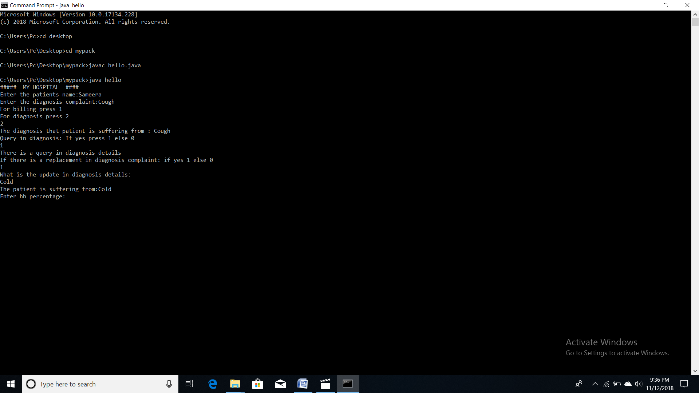

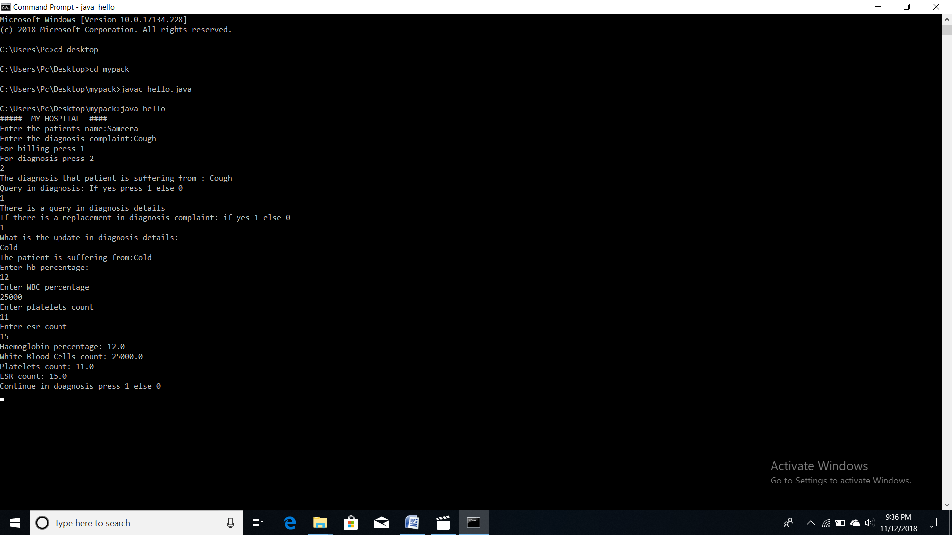

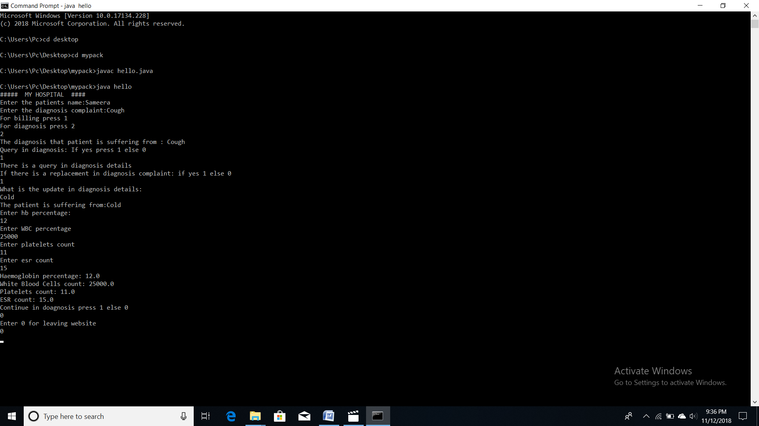

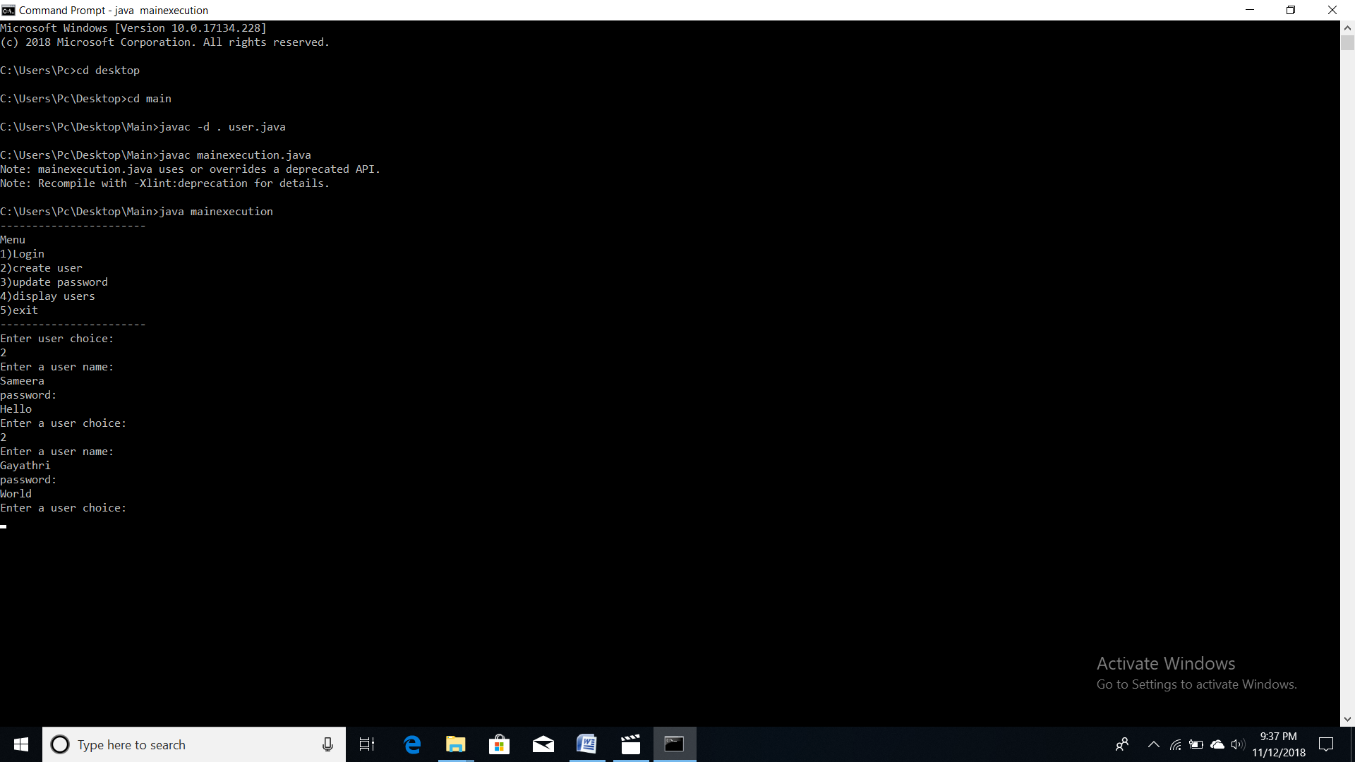

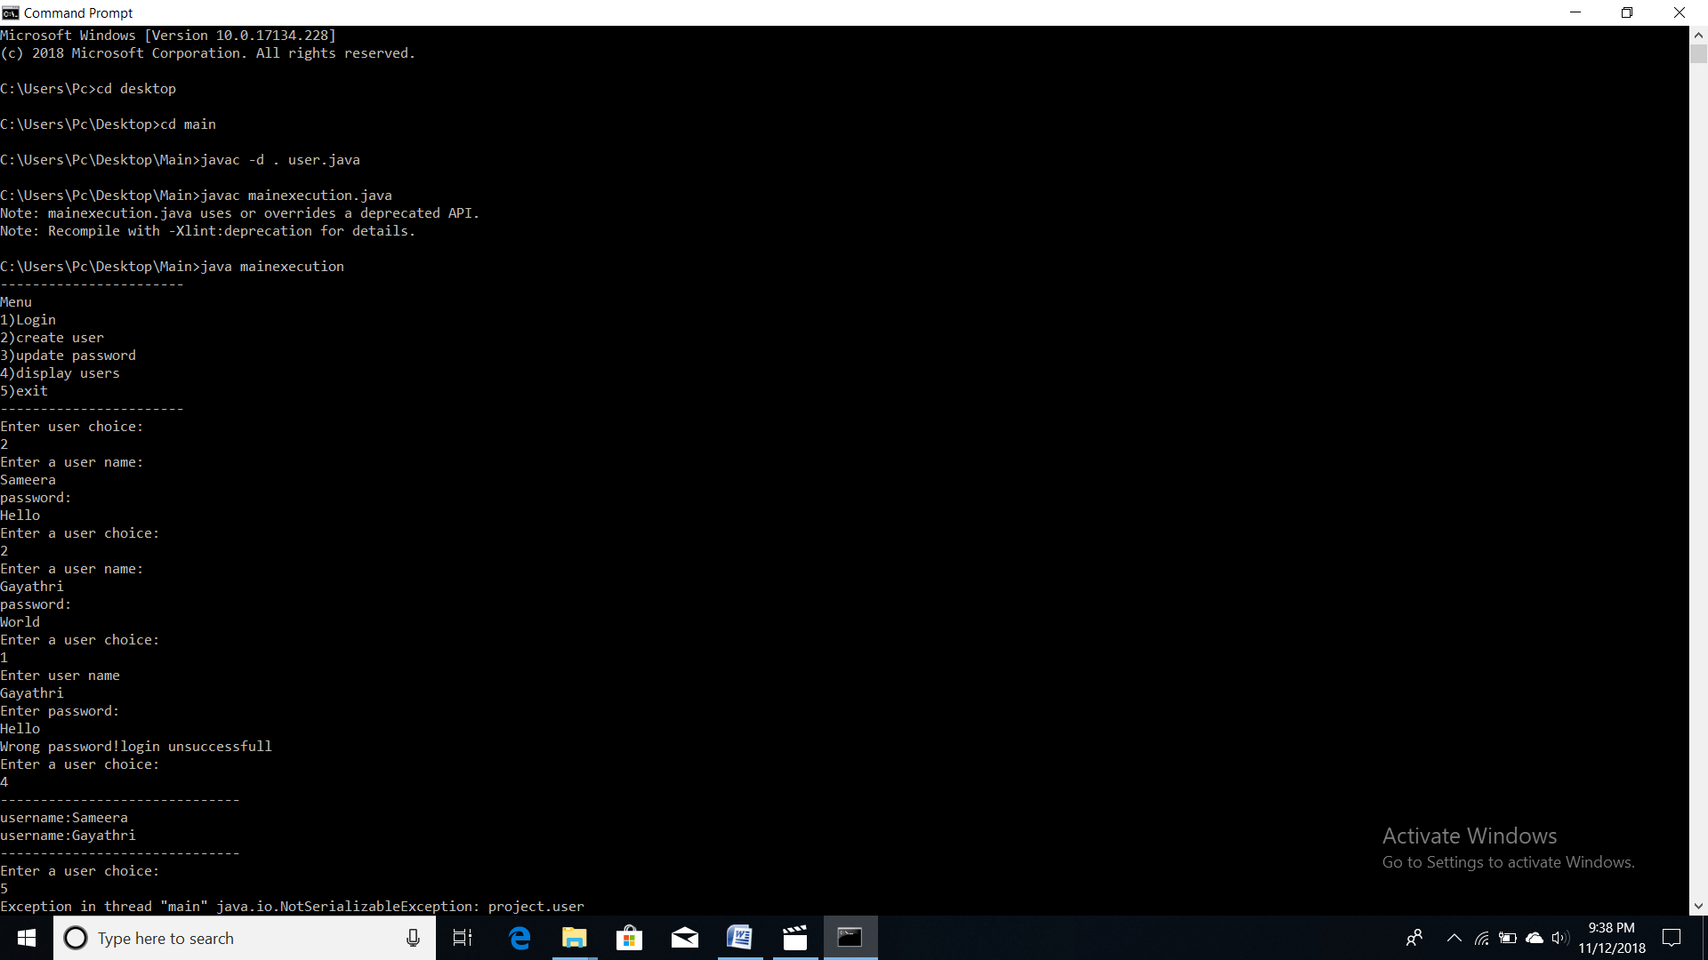

- CONCLUSION

By using this project we can handle the data of the patients easily and change and access them easily. And we can maintain these records for any long time and also the patients can also excess the information. So these can be accessed any where any time by the patients. So this project can develop further and can be used in many hospitals.

- REFERENCES

https://github.com/
https://www.geeksforgeeks.org/
http://1000projects.org/

